MOBILE ASPECTS
Guide to Run Service on Raspberry
Technical Reference Documentation

Document Version | Version 1.0.0(1)
Date | December 2025
Initiated By | M. Rahim
Organization | Mobile Aspects
Classification | Confidential – Internal Use Only
Status | Draft

Guide to Run service on Raspberry

Setting Up a Systemd Service for send.py on Raspberry Pi.
Create and Edit the systemd Service File. Open the service file:
sudo nano /etc/systemd/system/send.service
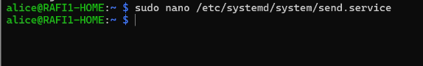

Insert the following content:
================================================
[Unit]
Description=Send Flask App
After=network-online.target mosquitto.service
Wants=network-online.target mosquitto.service

[Service]
Type=simple
User=alice
WorkingDirectory=/home/alice/broker
ExecStart=/bin/bash -c "sleep 10 && /home/alice/broker/venv/bin/python /home/alice/broker/send.py"
Environment=PYTHONUNBUFFERED=1
Restart=always
RestartSec=5
StartLimitIntervalSec=0
TimeoutStartSec=0
KillSignal=SIGINT
StandardOutput=journal
StandardError=journal

[Install]
WantedBy=multi-user.target

=================================================
#note:
#Change home/alice with your home base

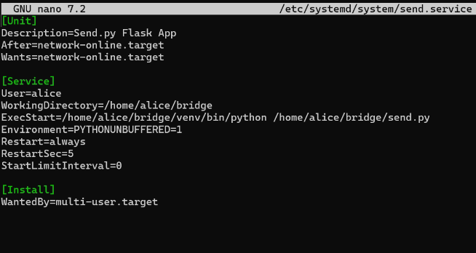
Save and exit. Check the file, makesure
ls -l /etc/systemd/system/send.service

Enable Python Access in Your Virtual Environment
ls -l /home/alice/broker/venv/bin/python
chmod +x /home/alice/broker/venv/bin/python
check valid: ls -l /home/alice/broker/venv/bin/python3
lrwxrwxrwx 1 alice alice 16 Jan 28 15:01 /home/alice/broker/venv/bin/python3 -> /usr/bin/python3
/home/alice/broker/venv/bin/python --version

#Change home/alice with your home base

Load and Start the Service
Reload system to apply changes:
sudo systemctl daemon-reload

Enable the service to start automatically on boot:
sudo systemctl enable send.service

Start the service now:
sudo systemctl start send.service

Stop the service:
sudo systemctl stop send.service

Disable the service so it does not start automatically:
sudo systemctl disable send.service

Check the service status:
sudo systemctl status send.service

After the service is running, make sure change your mosquito.conf at: etc/mosquito with:

# ======================================================
# MOSQUITTO CONFIG
# ======================================================
listener 1883 0.0.0.0
protocol mqtt
allow_anonymous true

# WebSocket listener (optional)
listener 9001 0.0.0.0
protocol websockets
allow_anonymous true

pid_file /run/mosquitto/mosquitto.pid

persistence true
persistence_location /var/lib/mosquitto/

log_dest file /var/log/mosquitto/mosquitto.log

include_dir /home/alice/broker/conf.d

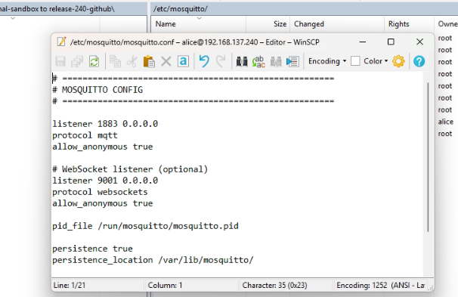

After the reader is running, you need to set up the Broker IP, which is taken from the Windows IP, by visiting:
http://ip.raspberry:8082.
But before it, send command:
sudo apt update
sudo apt install nbtscan
#for get cabinet name/hostname
Nex after visit http://ip.raspberry:8082. Enter your Windows IP
For example, if the Windows IP is 192.168.200.139
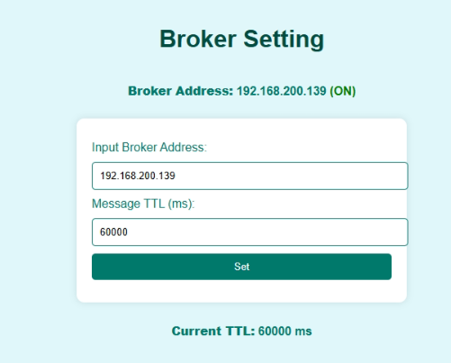

Enter the Windows IP in the Broker Address input field, and set the desired TTL.
The default value is 60000 ms (1 minute.)

Document Control
Field | Details
Document Title | Guide to Run Service on Raspberry — Technical Reference
Version | 1.0.0(1)
Initiated By | M. Rahim
Organization | Mobile Aspects
Date | December 2025
Review Cycle | As required upon system changes

This document is the property of Mobile Aspects and is intended for internal use only. Unauthorized distribution or reproduction is prohibited.

